Received 8/23/2016
Clerk-Treasurer email

ORDINANCE NO. 2016-10
AN ORDINANCE VACATING TWO HALF-STREET RIGHTS-OF-WAY
OFF OF SUPERIOR DRIVE
IN THE CITY OF AUBURN, INDIANA

SUMMARY
This ordinance vacates two half-street rights-of-way platted as part of the Amended Donald Shutt Addition to the City of Auburn in accordance with Indiana Code §36-7-13-12. The half-streets are off of Superior Drive, east of Dewey Street and west of Tecumseh Court.
More specifically, the two rights-of-way are labeled as “half-streets” contained within and on the east edge of the Amended Donald Shutt Addition to the City of Auburn, Indiana.
The first half-street right-of-way lies east of Lot 19 of the Amended Donald Shutt Addition extending 25-feet east to Lot 7 of the Indian Village Subdivision First Addition. It is bounded by Superior Drive right-of-way to the south and extends 125-feet north to the north edge of the Amended Donald Shutt Addition.
The second half-street right-of-way lies east of Lot 20 of the Amended Donald Shutt Addition extending 25-feet east to Lot 1 of the Indian Village Subdivision First Addition. It is bounded by Superior Drive right-of-way to the north and extends 125-feet south to the south edge of the Amended Donald Shutt Addition.
The City of Auburn shall retain a public utility easement over said real estate in accordance with Indiana Code Section 36-7-3-16. A full copy of said ordinance is available for inspection at the office of the Clerk-Treasurer City of Auburn or on the City of Auburn’s internet web site at www.ci.auburn.in.us.
.

X | Recorder’s Office |  | X | Publish Public Hearing
 | Auditor’s Office |  | Tuesday, September 20, 2016
 | Clerk’s Office |  | X | Publish O/R after Adoption
 | Other
X | Building Department
X | Engineering Department
 | DeKalb County Plan Commission
X | Internet Code Site – Council Ordinances

ORDINANCE NO. 2016-10
AN ORDINANCE VACATING TWO HALF-STREET RIGHTS-OF-WAY
OFF OF SUPERIOR DRIVE
IN THE CITY OF AUBURN, INDIANA

WHEREAS, a request to vacate certain undeveloped public rights-of-way has been made to the City of Auburn, Indiana and said request has been formalized into a petition by the Department of Building, Planning and Development;

WHEREAS, the City of Auburn desires to vacate certain undeveloped rights-of-way more particularly located as follows:

Two rights-of-way labeled as “half-streets” contained within and on the east edge of the Amended Donald Shutt Addition to the City of Auburn, Indiana.

The first half-street right-of-way lies east of Lot 19 of the Amended Donald Shutt Addition extending 25-feet east to Lot 7 of the Indian Village Subdivision First Addition. It is bounded by Superior Drive right-of-way to the south and extends 125-feet north to the north edge of the Amended Donald Shutt Addition.

The second half-street right-of-way lies east of Lot 20 of the Amended Donald Shutt Addition extending 25-feet east to Lot 1 of the Indian Village Subdivision First Addition. It is bounded by Superior Drive right-of-way to the north and extends 125-feet south to the south edge of the Amended Donald Shutt Addition.

WHEREAS, a Public Hearing of the City of Auburn Common Council was held on September 20 2016 at 6:00 PM in the Auburn Common Council Chambers regarding the petition for vacation; and

WHEREAS, the City of Auburn has provided notice, pursuant to Indiana Code §36-7-3-12(c) and 5-3-1 et. seq. that it desires to vacate certain public rights-of-way; and

WHEREAS, a second reading of the Ordinance was held on September 20, 2016, and

WHEREAS, due consideration and opportunity has been given for public notice and comment.

IT IS NOW THEREFORE ORDAINED BY THE COMMON COUNCIL
OF THE CITY OF AUBURN, INDIANA THAT:

Section 1.
For those undeveloped portions of right-of-way see Exhibit A, consisting of one (1) page, which is attached hereto and made a part hereof further setting forth the area being

vacated. The entire vacated right-of-way shall be awarded to the adjoining landowners to the west that are also part of the Amended Donald Shutt Addition.

Section 2.
The Municipal City of Auburn shall retain an easement across the vacated rights-of-way for the purpose of providing, maintaining, and expanding utilities in the future. The Municipal City of Auburn shall have the right to maintain, expand, and repair utilities within said vacated rights-of-way.

BE IT FURTHER ORDAINED that this Ordinance shall be in full force and effect
from and after publication of the summary of this Ordinance in a newspaper of general
circulation in DeKalb County, Indiana. A full and complete copy of the Ordinance shall
be kept on the City of Auburn website under the Council information at
www.ci.auburn.in.us.

PASSED AND ADOPTED by the Common Council of the City of Auburn,
Indiana, this 20th day of September, 2016.
________________________________
James Finchum, Councilmember

ATTEST:

_________________________
Patricia Miller, Clerk-Treasurer

Presented by me to the Mayor of the City of Auburn, Indiana, this 20th day of
September, 2016.

______________________________
PATRICIA MILLER, Clerk-Treasurer

APPROVED AND SIGNED by me this 20th day of September, 2016.

_____________________________
NORMAN E. YODER, Mayor

VOTING: AYE NAY

Kevin Webb

James Finchum

Dennis (Matthew) K. Kruse II

Todd Sanderson

Michael Watson

Dennis Ketzenberger

Michael Walter
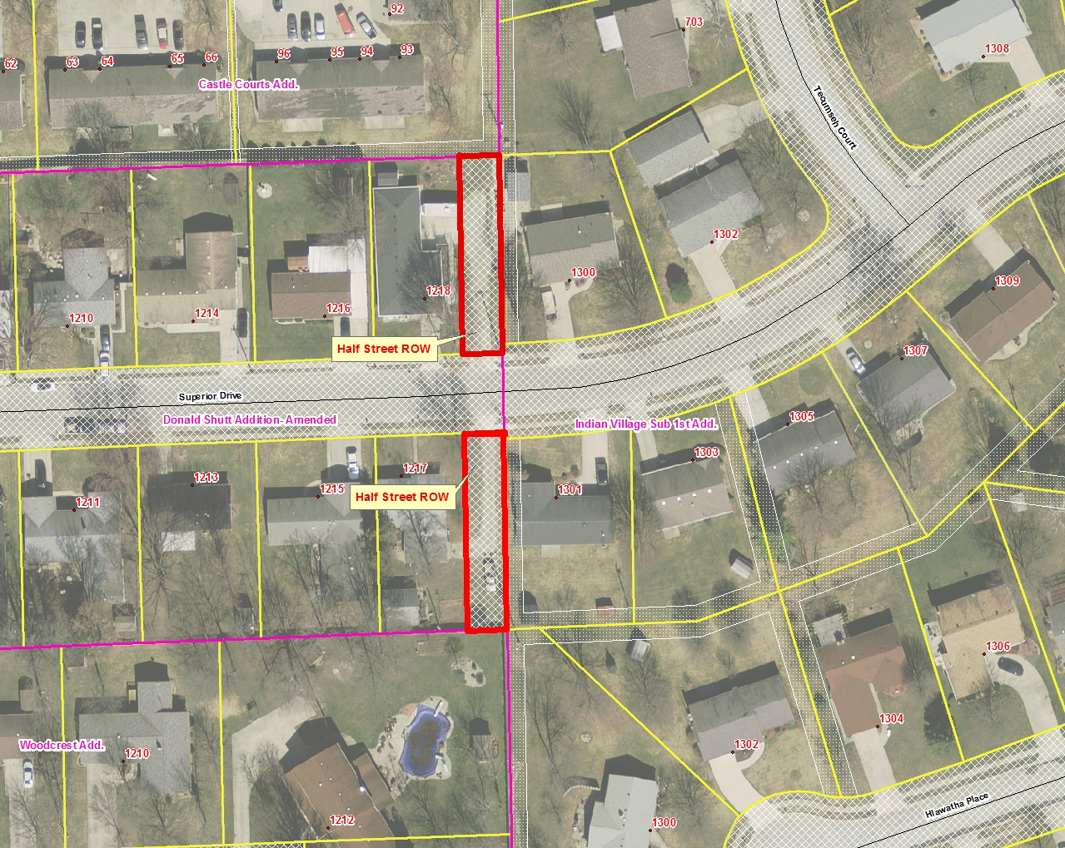
Exhibit A

