Received 04/18/2017 via email
Clerk-Treasurer mailbox
Auburn, Indiana

ORDINANCE NO. 2017-05

AN ORDINANCE
TO AMEND THE ZONING MAP
OF THE CITY OF AUBURN

SUMMARY

An ordinance amending the Zoning Map of the City of Auburn, Indiana.

_________________ Recorder’s Office _________ Publish Public Hearing
_________________ Auditor’s Office ____________________________
_________________ Clerk’s Office _______ Publish O/R after adoption
_________________ Other ____________________________
Building Department
Engineering Department
DeKalb County Plan Commission
Internet Code Site
ORDINANCE NO. 2017-05

AN ORDINANCE
AMENDING THE ZONING MAP
OF THE CITY OF AUBURN

WHEREAS, Ordinance No. 89-01, as amended, adopted a Zoning Map for the City of Auburn, Indiana; and

WHEREAS, in accordance with Indiana Code §36-7-4-205, the DeKalb County Commissioners and the Auburn Common Council have executed an Inter-Local Cooperation Agreement to grant the City of Auburn authority to exercise Extra-Territorial Jurisdiction with regard to planning and zoning in specific areas outside the corporate limits; and

WHEREAS, the City of Auburn Plan Commission has conducted a Public Hearing on April 11, 2017 as required by law in regard to a request to amend the Zoning Map of the City of Auburn; and

WHEREAS, the City of Auburn Plan Commission at its April 11, 2017 meeting forwarded a favorable recommendation to the Auburn Common Council by a vote of nine in favor and zero opposed concerning the rezoning of certain real estate located within the City of Auburn, Indiana’s Extra-Territorial Jurisdiction; and

WHEREAS, Indiana Code section §36-7-4-600 et. Seq provides for amendments to the zoning map of a municipality by ordinance of the municipality, and

NOW THEREFORE, BE IT ORDAINED BY THE COMMON COUNCIL OF THE CITY OF AUBURN, INDIANA:

THAT, the Zoning Map of the City of Auburn shall be amended in the following manner:
The zoning of the tract of land bound by County Road 11A, County Road 427, and County Road 23 shall be changed to the C-2 (General Commercial) District. The legal description is attached hereto as Exhibit A, and the tract of land is illustrated in Exhibit B, also attached hereto.

BE IT FURTHER ORDAINED that this Ordinance be in full force and effect after its passage by the Common Council and after the occurrence of all other actions required by law.
PASSED AND ADOPTED by the Common Council of the City of Auburn,
Indiana, this ______ day of ______________________, 2017.

________________________________
JAMES FINCHUM, Council Member

ATTEST:

_____________________
Patricia Miller, Clerk-Treasurer

Presented by me to the Mayor of the City of Auburn, Indiana, this ______ day of
____________________, 2017.

_____________________________
PATRICIA MILLER, Clerk-Treasurer

APPROVED AND SIGNED by me this _____ day of _________, 2017.

_____________________________
NORMAN E. YODER, Mayor

VOTING: AYE NAY

Dennis (Matthew) K. Kruse II
James Finchum
Wayne Madden
Michael Watson
Kevin Webb
Dennis Ketzenberger
Michael Walter

EXHIBIT A
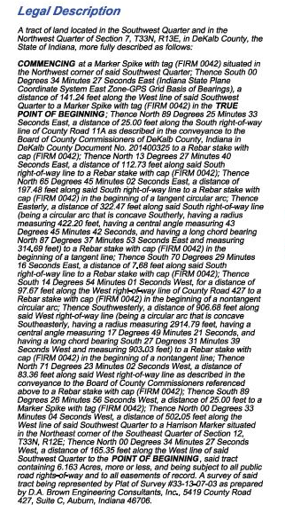
EXHIBIT B

